

Product Catalog System

How to create a supplier
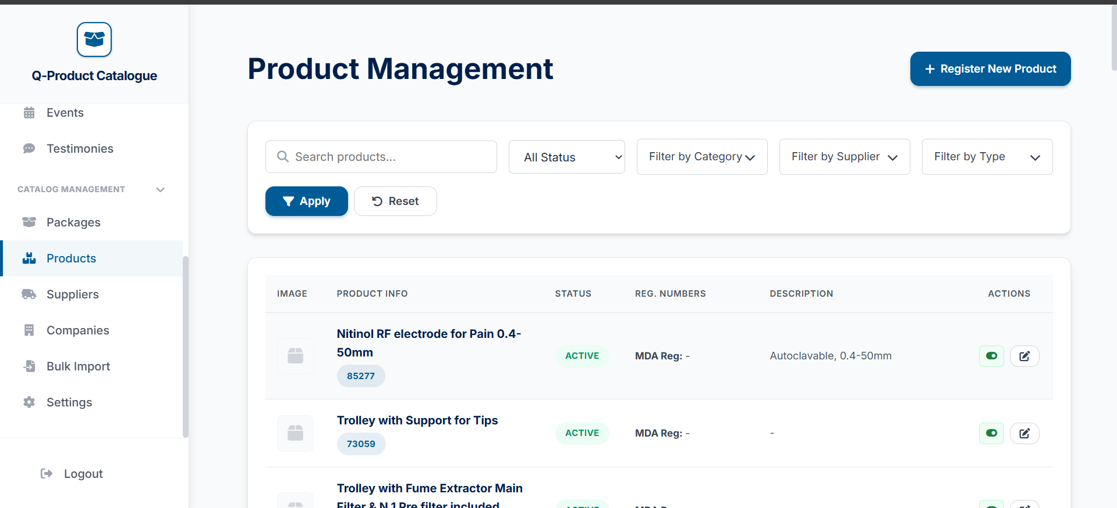

Go to the product tab


Click on the add new product button at the top

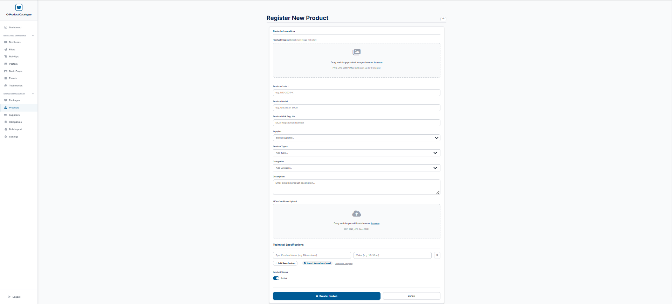
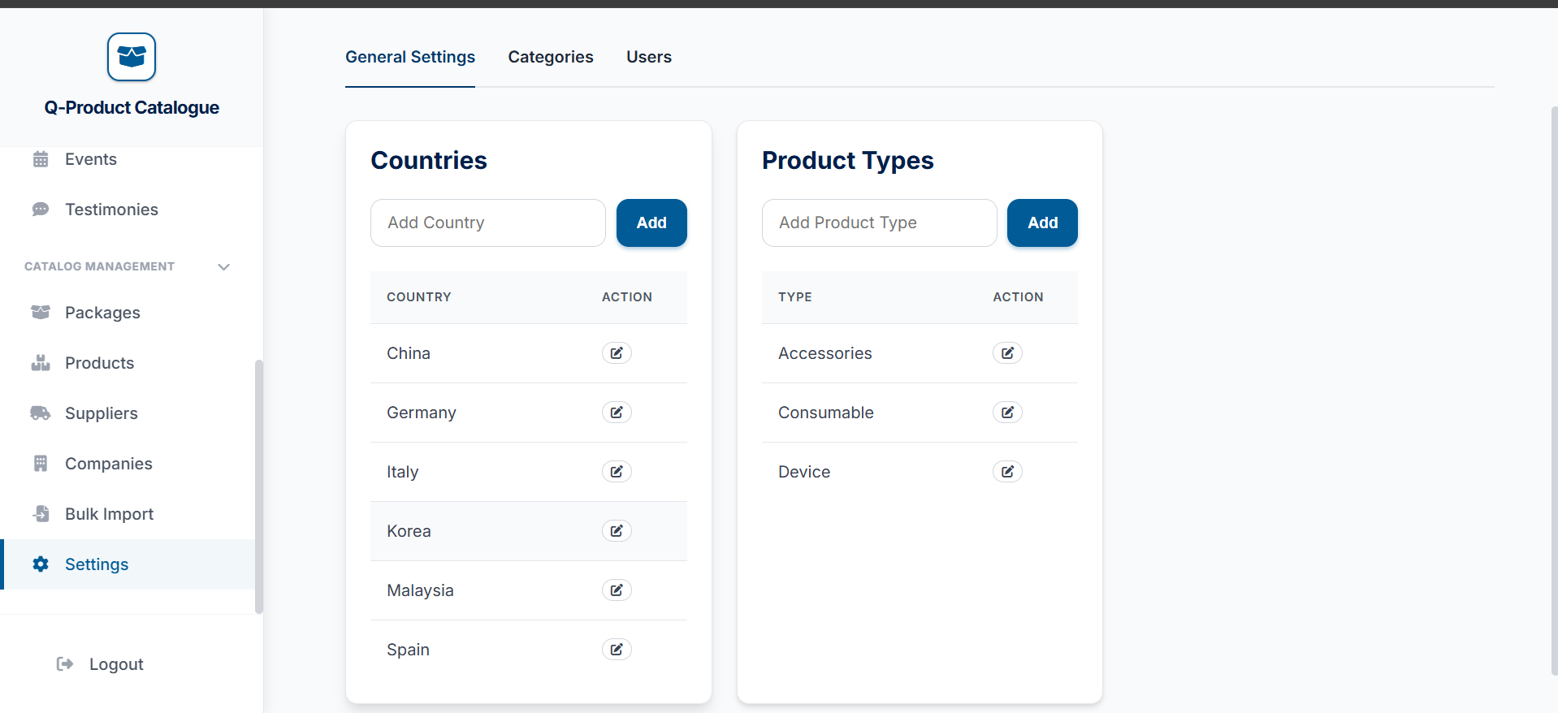

After filling, just press the register product button
Fill out this form, and the details that are starred are required to fill in, and for the product specifications, you can use the Excel template to fill in to make things easier
Enter the country you want here
Enter the country you want here


Enter the country you want here

